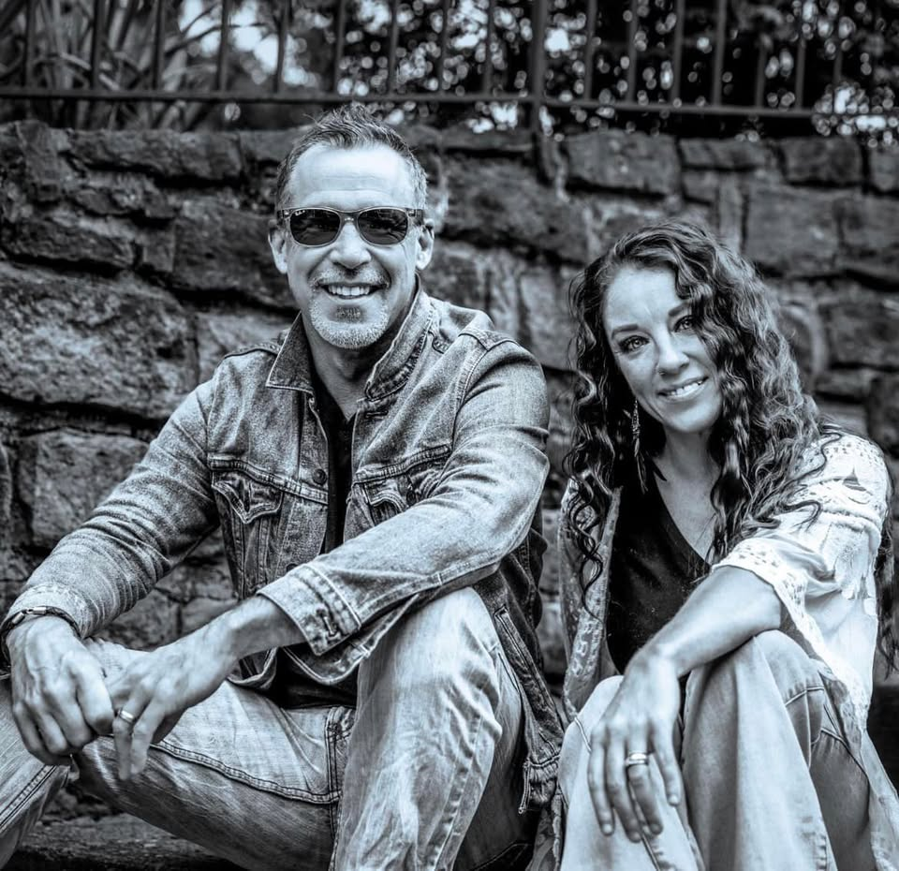
An Evening with the Gina & Johnny Duo at the Villa Hills Civic Club!
Saturday July 12th from 8pm to 10pm ( Open to the Public)

Join us for a memorable night of live music as the incredible Gina & Johnny Duo take the stage at our brand-new Civic Club building—for the very first time!
Featuring longtime Villa Hills resident Johnny Fink and his talented musical partner Gina, this dynamic duo will bring their signature sound to the VHCC in a special performance dedicated to raising funds that will help us continue enhancing our new establishment.

Make it a day to remember! Earlier in the day, enjoy our Annual Car Show, then stick around for an evening of fantastic live music, community spirit, and great company.
Let’s celebrate music, community, and the future of VHCC—together!

